Visit vote.ecuguild.org.au
Here you can click on Candidate List to see whose running and read their manifesto.
When you’re ready to vote, click on ‘Student Login’ at the top right.
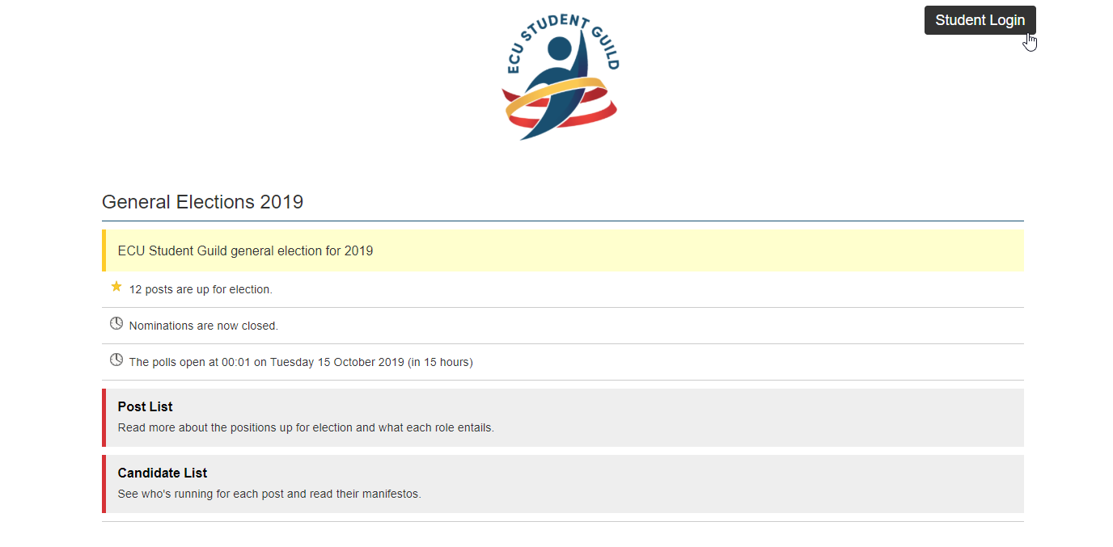
Use your ECU username and password to log in.
Once you are logged in the ‘Post List’ (this is a list of positions), ‘Candidate List’ (the candidates in the election) and ‘Vote Now’ options will appear at the bottom of the page. Click ‘Vote Now’ to begin the voting process. You can always return to this page later and do not need to complete voting in a single session but the voting system will close at Midnight on Thursday the 17th October.
When you select a position you will see a list of candidates who are contesting the position with empty boxes to the left of their names. Using these boxes, number the candidates in your order of preference starting with the number 1 indicating your first preference, 2 being your second and so on in an unbroken sequence (you can’t skip from 1 to 3, it must be 1, 2, 3). Candidates can be numbered in any order that you choose.
You do not need to number every box but must indicate at least one (1) preference else your vote will be informal (meaning that it will not count). Once you have finished entering your preferences, you can select ‘no further preferences’ to preview your vote before submitting it.
Click ‘cast vote’ to submit your ballot and cast your vote. This will save your vote.

Repeat this process for all positions that you are eligible to vote for before Midnight on Thursday 17th of October. If you have any questions, or are having technical issues trying to cast your vote, please contact the Guild on 6304 2640 during office hours 8am-4pm, or contact out of hours:
Mr. Garry Duijckers  RETURNING OFFICER  Mobile: 0418 912 737  ro2019@ecuguild.org.au | Melissa Johnston  Acting Guild CEO  Mobile: 0419 936 836  m.johnston@ecuguild.org.au | Lauren Reed  Marketing Officer  Mobile: 0401 334 714  l.reed@ecuguild.org.au

